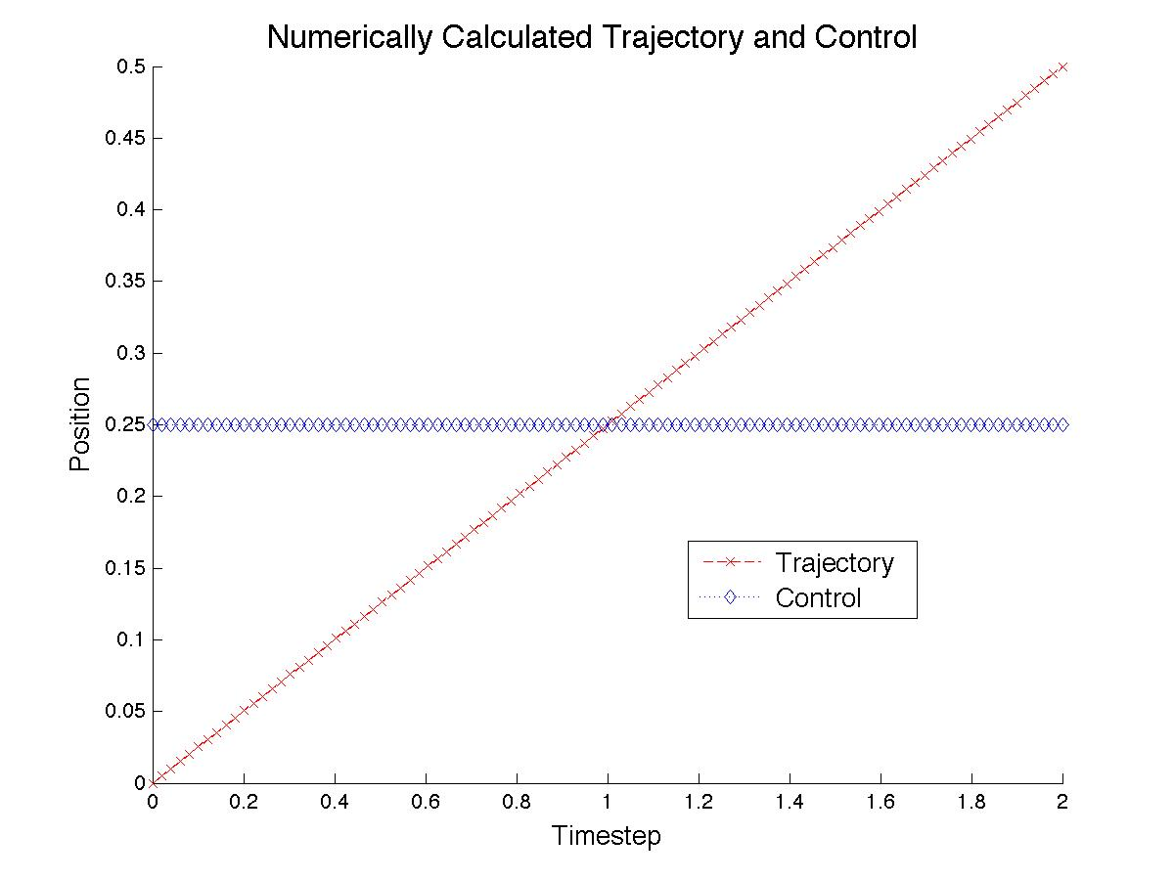

function sol = NumSolveCode(Start,Stop,Guess)

sol = bvp4c(@OdeFunc, @BCFunc, solinit);

function dxdy = OdeFunc(~,y)

dxdy = [y(2);...

0];

function res = BCFunc(ya, yb)

res = [ya(1) - 0;...

yb(1) - .5];